Project Development Phase
Performance Test

Date | 18 July 2026
Team ID | SWTID-2026-5360
Project Name | Heart Disease Analysis
Maximum Marks

Model Performance Testing:

S.No. | Parameter | Screenshot / Values
 | Data Rendered | Heart Disease 2020 dataset successfully imported into Tableau. All records displayed correctly.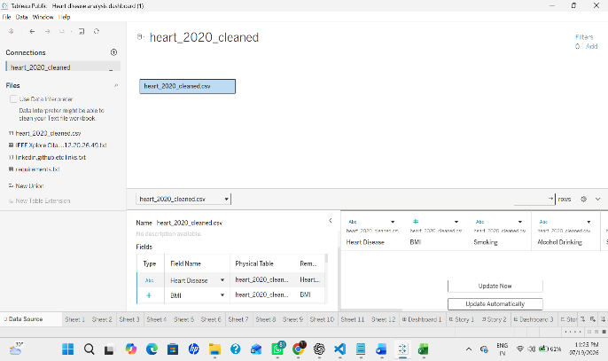
 | Data Preprocessing | Verified data types, checked for missing values, organized Dimensions and Measures.  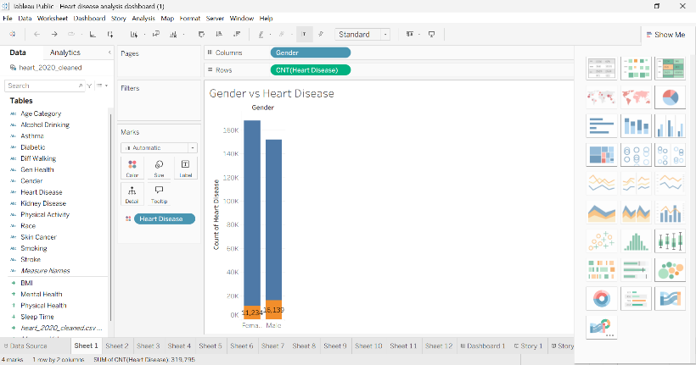
3. | Utilization of Filters | Filters implemented for Age Category, Gender, Smoking, Diabetes, and General Health.  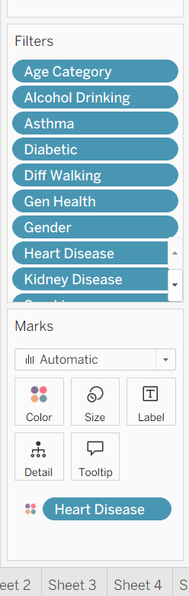
4. | Calculation fields Used | No calculated fields used.
5. | Dashboard design | No of Visualizations / Graphs - 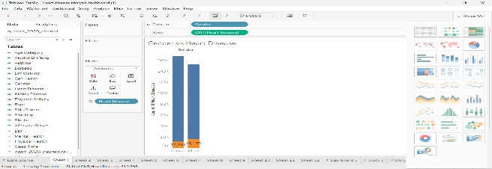
6 | Story Design | 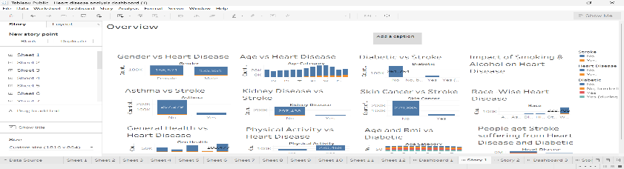  No of Visualizations / Graphs -

